Import Data using Transform Maps (Spreadsheet)

Phase-4 -- Project Planning Phase

Date | 30/09/2026
Team Id | SWTID-2026-4384
Project Name | Import Data using Transform Maps (Spreadsheet)
Project Guide Name | Mr.M.Salaimani M.Sc.,M.Phil.

Team Leader :

  - Azhagubhuvaneshwari G - bhuvaniganeshan2007@gmail com

Team Members :

  - Mathumithral B S – mathumithral2006@gmail.com
  - Krishnaveni S – krishnaveni1522007@gmail.com
  - Sivadhurkka K– ksivadhurkka@gmail.com

Project Objectives Planning

Define clear objectives to guide the implementation and verification steps:

- Import employee data from a spreadsheet into ServiceNow reliably.
- Use an Import Set as a staging area (u_employee_import).
- Use a Transform Map to map and move data into the Employee Test table (u_employee_test).
- Maintain Employee ID as the primary identifier and Coalesce key to prevent duplicates.
- Support both insert (new records) and update (existing records) operations.
- Validate transformed records and produce three reports and a centralized dashboard.

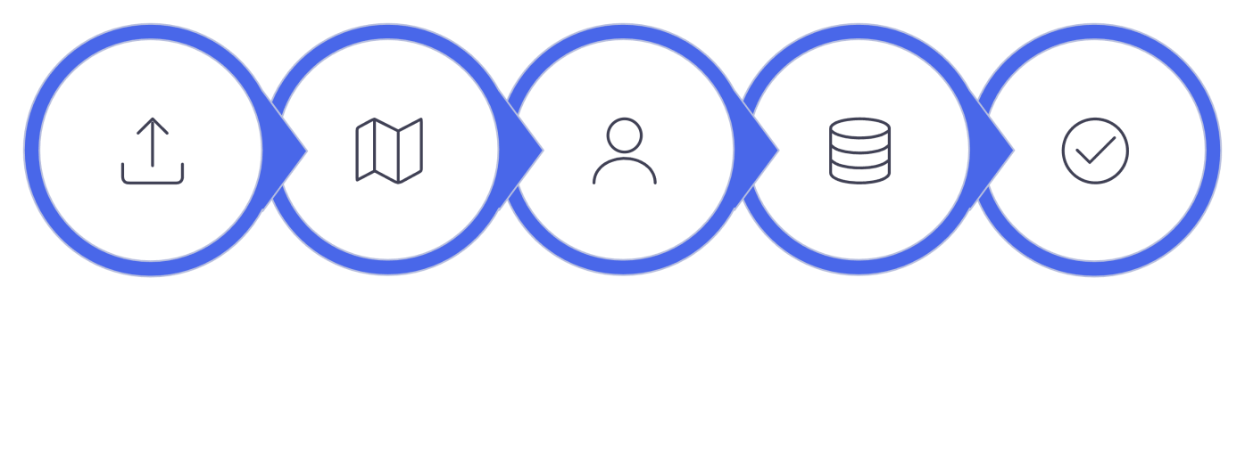
Import
Transform
Match
Upsert
Validate

- Prepare the spreadsheet data before loading it into the ServiceNow Import Set.
- Create the Employee Import staging table to receive spreadsheet records.
- Create the Employee Test target table to store transformed employee records.
- Configure the Transform Map between the Employee Import and Employee Test tables.
- Map all five employee fields correctly during the transformation process.
- Use Auto Map Matching Fields where the source and target field names match.
- Use Mapping Assist for fields that require manual mapping.
- Test the transformation using new and existing Employee IDs.
- Verify the transformation results through Transform History and the Employee Test table.
- Provide employee data visibility through department, location, and employee-list reports on the
Employee Analytics Dashboards dashboard.

Data Planning

Plan the source and target data structure and preparation rules before importing.

- Required fields in source and target: Employee ID, Employee Name, Email, Department, Location.
- Use consistent field names and formats across spreadsheet and ServiceNow tables.
- Place data in Sheet 1 with a header row (row 1) describing each column.
- Ensure Employee ID is populated for every row to enable Coalesce matching.
- Create a sample file named Sample Spreadsheet.xlsx for iterative testing.


Create
Spreadsheet
Add Required
Fields
Enter
Records
Review
Source Data
Download
Sample

- Define the Employee ID as the key employee identification field.
- Prepare employee data in a structured spreadsheet format before importing.
- Ensure each spreadsheet column corresponds to a field in the Employee Import and Employee Test
tables.
- Keep Employee Name values ready for insertion or update during transformation.
- Prepare valid Email values for each employee record.
- Include Department information for department-wise reporting.
- Include Location information for location-wise reporting.
- Plan the data structure so the same employee can be identified during repeated imports.
- Prepare both new employee records and existing employee records with changed values for testing.
- Use the prepared sample data to verify the import, transformation, update, and duplicate- prevention process.

Table and Staging Planning

Define the staging and target tables, their purpose, and the rationale for separation.

- Employee Import (staging): Label = Employee Import, Table = u_employee_import — receives raw spreadsheet rows.
- Employee Test (target): Label = Employee Test, Table = u_employee_test — final store for transformed, validated records.
- Keep staging and target separate to allow review and corrective action prior to transformation.
- Maintain identical field set between staging and target to simplify mapping.


Spreadsheet
Employee Import
Transform Map
Employee Test

- Define Employee Import as the staging table for uploaded spreadsheet data.
- Define Employee Test as the target table for transformed employee records.
- Use u_employee_import as the source table for the Transform Map.
- Use u_employee_test as the target table for the Transform Map.
- Plan the staging table to hold the imported spreadsheet rows before transformation.
- Plan the target table to contain the resulting employee records after transformation.
- Create the target table with fields for Employee ID, Employee Name, Email, Department, and Location.
- Verify that the required fields are available in the target table before transformation.
- Plan the table structure so source fields can be mapped to corresponding target fields.
- Verify the target Employee Test records after transformation to confirm that the planned table structure works correctly.

Import Set Planning

Plan the Import Set configuration and standard operating steps for loading spreadsheet data.

- Import Set label: Employee Import; Table: u_employee_import.
- Source file: Sample Spreadsheet.xlsx, Sheet number: 1, Header row: 1.
- Load spreadsheet data into the staging table and perform an initial review prior to running transforms.
- Reuse the Employee Import table for iterative test imports; clear or archive staging rows as needed.
- Plan the Import Set as the staging area for spreadsheet employee data.
- Confirm that the Import Set table is created with the label Employee Import.
- Verify that the table name is u_employee_import.
- Plan the spreadsheet upload using Sample Spreadsheet.xlsx.
- Select Sheet 1 during the file upload process.
- Use row 1 as the header row so the column names are identified correctly.
- Verify that the uploaded data is available in the Employee Import staging table.
- Review the imported rows before starting the Transform operation.
- Check the Import Set status and confirm that the file is processed successfully before transforming the data.
- Plan to use the same Import Set table for subsequent test uploads and transformation activities.


Source File
Sample
Spreadsheet.xlsx
Header Row
Set Header Row 1
Review
Check imported
records
Select Sheet
Choose Sheet 1
Load Data
Import to Employee Import

Transform Map Planning

Design the Transform Map to map source fields to target fields and prepare mappings for execution.

- Transform Map Name: Sample Spreadsheet Import.
- Source Table: u_employee_import; Target Table: u_employee_test.
- Plan source-to-target mappings for all five fields; enable Auto Map where column names match.
- Use Mapping Assist for remaining fields and review each mapping for type compatibility.
- Plan the Transform operation and document the expected Insert/Update behavior.
- Plan the Transform Map after creating the Employee Import and Employee Test tables.
- Confirm that the source table contains the required employee fields before transformation.
- Verify that the target table contains matching fields for the imported employee data.
- Plan the mapping for Employee ID as the key field for identifying employee records.
- Plan mappings for Employee Name, Email, Department, and Location.
- Review the field names and ensure the source and target fields are correctly connected.
- Use Auto Map Matching Fields when source and target column names are the same.
- Use Mapping Assist to manually connect fields that are not automatically matched.
- Review all field mappings before running the Transform operation.
- Record the expected transformation result: new Employee IDs are inserted, while existing Employee IDs are updated when Coalesce is enabled.

Employee
Import
Prepare source spreadsheet
Select Target
Choose Employee Test table
Review & Save
Adjust mappings and save map
Create
Transform
Map
Define new map for import
Auto Map
Fields
Run automatic field matching

Coalesce and Duplicate Management Planning

Establish duplicate prevention logic and decisions at transformation time.

- Assume repeated imports of similar data; use Coalesce to prevent duplicates.
- Set Employee ID as the Coalesce field to identify existing records.
- Behavior: existing Employee ID → Update existing record; new Employee ID → Insert new record.
- Plan to review transformation history and sample records to verify Coalesce results.


Apply Outcome
Insert, update, or ignore
ID Exists?
Decision: update or insert
Check ID
Lookup Employee ID
Import Record
Receive employee data

Testing and Validation Planning

Define test scenarios, expected outcomes, and the validation checklist to confirm correctness.

- Test the initial import and verify records in Employee Test.
- Scenario documented: upload 4 rows — 2 new Employee IDs, 2 existing IDs with changed data.
- Expected first run: 2 Inserted, 2 Updated. Repeating same spreadsheet: 0 Inserted, 0 Updated, 4 Ignored.
- Validate inserted and updated results, review transformation history, and confirm no duplicates
exist in Employee Test.
- Verify that the uploaded spreadsheet contains the required five fields before starting the import.
- Confirm that the Employee Import table receives the uploaded spreadsheet data correctly.
- Check that the Transform Map uses the correct source table and target table.
- Verify that each source field is mapped to the corresponding target field.
- Test whether new Employee IDs create new records in the Employee Test table.
- Test whether existing Employee IDs update the existing employee records instead of creating duplicates.
- Verify that changed Employee Name and Email values are updated correctly for existing IDs.
- Review the Transform History to confirm the number of inserted, updated, and ignored records.
- Re-import the same spreadsheet and verify that previously processed records are ignored.
- Perform a final validation of the Employee Test table to confirm the imported data and duplicate- prevention behavior are correct.

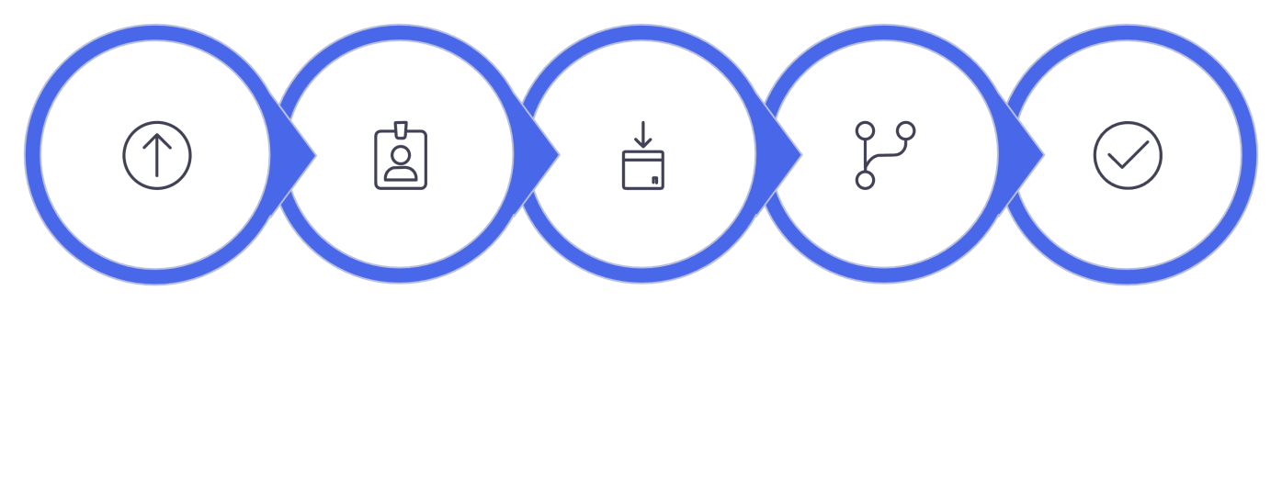
Initial Import
Verify
Employee Test
Import New +
Existing
Run
Transform
Check
Results

Reporting and Dashboard Planning

Plan the reports and dashboard that will provide insights from the Employee Test table.

- Report 1 — Employees by Department: Source = Employee Test, Type = Pie Chart, Group by Department, Aggregation = Count.
- Report 2 — Employees by Location: Source = Employee Test, Type = Bar Chart, Group by Location, Aggregation = Count.
- Report 3 — Employee List Report: Source = Employee Test, Type = List with columns Employee ID,
Name, Email, Department, Location.
- Dashboard: Employee Analytics Dashboards — include the three reports and configure sharing by Users, Groups, and Roles.
- Plan all reports using the Employee Test table as the report source.
- Ensure the reports use the imported employee records for analysis.
- Plan the Department report to show the distribution of employees across departments.
- Plan the Location report to show the distribution of employees across different locations.
- Use Count aggregation to determine the number of employee records in each group.
- Configure appropriate report formats so the grouped employee data is easy to understand.
- Include important employee fields in the Employee List Report for detailed record viewing.
- Verify that the three reports display the expected Employee Test data after import and transformation.
- Add the completed reports to the Employee Analytics Dashboards dashboard.
- Plan dashboard access by configuring appropriate Users, Groups, and Roles for sharing.

Validated
Data
Employee Test table validated
By
Department
Generate Employees by Department
Review & Save
Finalize and store reports
Create Reports

Set up report
templates
By Location
Generate Employees by Location

Activity Sequence and Planning Summary

Present the ordered activities required to complete implementation and a concise academic summary of the planning phase.

- Sequence highlights: prepare spreadsheet → create staging and target tables → create and save
Transform Map → configure Coalesce → execute transforms → validate and test → create reports
→ assemble dashboard → configure access → final review.
- Planning establishes the structure and sequence needed to implement a repeatable, auditable employee data import process using ServiceNow Import Sets and Transform Maps.
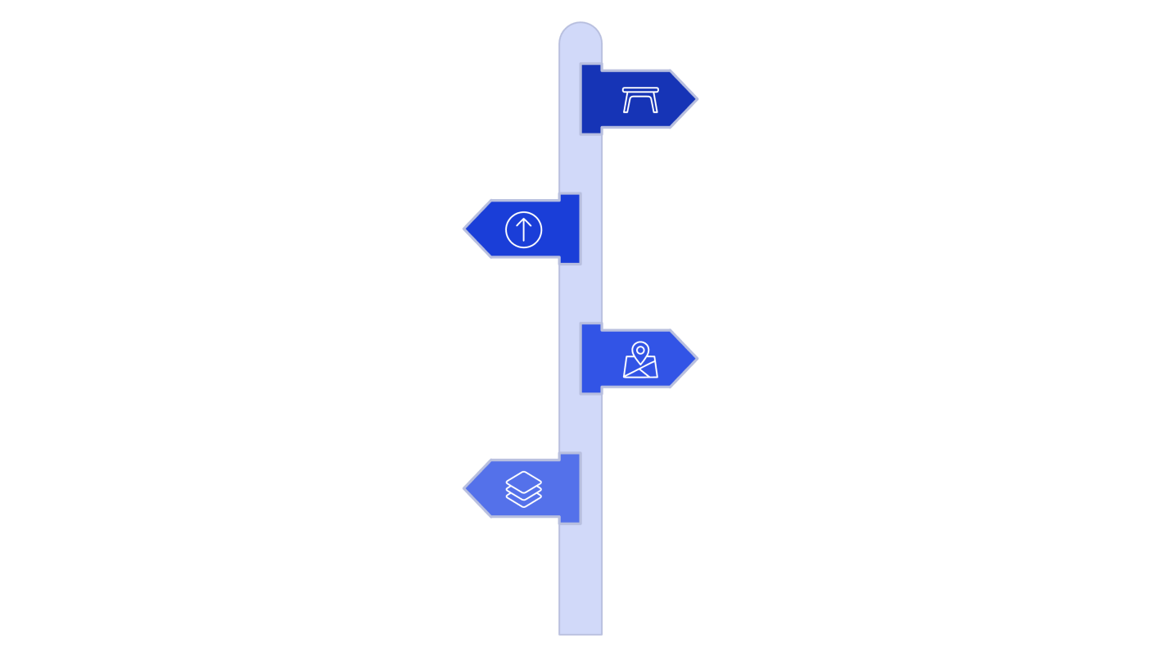
Prepare Data
Prepare spreadsheet and staging
Map &
Transform
Create transform map and field mapping
Report &
Review
Create dashboards and final review
Validate &
Test
Build Tables
Create test and import tables
Execute
transformation and validate records
Spreadsheet Prep
Organize and validate source data.
Import Set Planning
Design staging and import workflows.
Transform Map Planning
Define mappings and transformation rules.
Coalesce Planning
Specify deduplication and merge logic.

